Computer Programming I — Homework Assignment #12

**Problem:** Design a UNI Air Domestic Flights Booking System

**Functions:**

1. Booking (訂票): Insert a new record into the binary file **Reservations.dat**. Any passenger cannot book twice the same flight on the same day.
2. Booking inquiry (訂票紀錄查詢): Input an ID number, then display the reservation information of the passenger.
3. Refund application (刪除訂票資料): Delete a record from the binary file **Reservations.dat**.

**Requirements:**

1. Global variables, except **airportName** , **fullFare** , **discount** and **maxNumReservations**, are not allowed.

**Remark:** The **flightNo** is unique in each flight.

The file record format of the file **Reservations.dat**:

**char flightNo[ 8 ]; // Flight number**

**char id[ 12 ]; // ID number**

**char name[ 8 ]; // Name**

**char mobile[ 12 ]; // Mobile phone number**

**char date[ 12 ]; // Departure date**

**int tickets[ 8 ];**

**// tickets[ 0 ]: not used**

**// tickets[ 1 ]: number of full fare tickets**

**// tickets[ 2 ]: number of child tickets**

**// tickets[ 3 ]: number of infant tickets**

**// tickets[ 4 ]: number of senior citizen tickets**

**// tickets[ 5 ]: number of impaired tickets**

**// tickets[ 6 ]: number of impaired companion tickets**

**// tickets[ 7 ]: number of military tickets**

The file record format of the file **Flight Schedule.dat**:

**char flightNo[ 8 ]; // Flight number**

**char aircraft[ 8 ]; // aircraft model**

**int departureAirport; // Departure airport code**

**int arrivalAirport; // Arrival airport code**

**char departureTime[ 8 ]; // Departure time**

**char arrivalTime[ 8 ]; // Arrival time**

**int dayWeek[ 7 ]; // the value of dayWeek[ i ] is 0 or 1**

**// dayWeek[ 0 ] == 1 if and only if the flight flies on Sunday**

**// dayWeek[ 1 ] == 1 if and only if the flight flies on Monday**

**// dayWeek[ 2 ] == 1 if and only if the flight flies on Tuesday**

**// dayWeek[ 3 ] == 1 if and only if the flight flies on Wednesday**

**// dayWeek[ 4 ] == 1 if and only if the flight flies on Thursday**

**// dayWeek[ 5 ] == 1 if and only if the flight flies on Friday**

**// dayWeek[ 6 ] == 1 if and only if the flight flies on Saturday**

The file record format of the file **Flight Seats.dat**:

**char date[ 12 ]; // Date**

**char flightNo[ 8 ]; // Flight number**

**int departureAirport; // Departure airport code**

**int arrivalAirport; // Arrival airport code**

**int availableSeats; // The number of available seats**

The screen dialog should appear as follows:

|  |
| --- |
| Welcome to UNI Air Domestic Flights Booking System  Input your choice:  1. Booking  2. Booking enquiry  3. Refund application  4. End  ? 1  Departure airport:  1. Taipei  2. Taichung  3. Chiayi  4. Tainan  5. Kaohsiung  6. Hualien  7. Taitung  8. Penghu  9. Kinmen  10. Beigan  11. Nangan  ? 1  Arrival airport:  6. Hualien  7. Taitung  8. Penghu  9. Kinmen  10. Beigan  11. Nangan  ? 8  Departure Date (Month):  1. 2022-12  2. 2023-1  3. 2023-2  4. 2023-3  5. 2023-4  6. 2023-5  ? 1  Day (18 ~ 31): 18  Taipei to Penghu / Depart date: 2022/12/18.  Flight Departure Arrival Fare No. Available Seats  9105 09:50 10:50 2296 2  8609 11:30 12:20 2296 4  8615 15:00 15:50 2296 5  8625 18:30 19:20 2296 5  Flight number: 9105  Number of infant tickets (0 ~ 2): 0  Number of full fare tickets (0 ~ 2): 3  Number of child tickets (0 ~ 2): 0  Number of senior citizen tickets (0 ~ 2): 0  Number of impaired tickets (0 ~ 2): 0  Number of impaired companion tickets (0 ~ 2): 0  Number of military tickets (0 ~ 2): 0  You can books a maximum of 2 passengers ( including children ).  Number of full fare tickets (0 ~ 2): 0  Number of child tickets (0 ~ 2): 1  Number of senior citizen tickets (0 ~ 2): 0  Number of impaired tickets (0 ~ 2): 0  Number of impaired companion tickets (0 ~ 2): 0  Number of military tickets (0 ~ 2): 0  Ticket information:  Date: 2022/12/18  Flight: B7-9105  Taipei -> Penghu  09:50 10:50  Child Fare TWD 1722 x 1  Total: 1722  ID number: 99  Name: 99  Mobile: 99  Booking completed!  Input your choice:  1. Booking  2. Booking enquiry  3. Refund application  4. End  ? 4  請按任意鍵繼續 . . . |

|  |
| --- |
| Welcome to UNI Air Domestic Flights Booking System  Input your choice:  1. Booking  2. Booking enquiry  3. Refund application  4. End  ? 1  Departure airport:  1. Taipei  2. Taichung  3. Chiayi  4. Tainan  5. Kaohsiung  6. Hualien  7. Taitung  8. Penghu  9. Kinmen  10. Beigan  11. Nangan  ? 1  Arrival airport:  6. Hualien  7. Taitung  8. Penghu  9. Kinmen  10. Beigan  11. Nangan  ? 7  Departure Date (Month):  1. 2022-12  2. 2023-1  3. 2023-2  4. 2023-3  5. 2023-4  6. 2023-5  ? 1  Day (18 ~ 31): 18  Taipei to Taitung / Depart date: 2022/12/18.  Flight Departure Arrival Fare No. Available Seats  8721 09:40 10:45 2460 4  8727 16:50 17:55 2460 9  Flight number: 8721  Number of infant tickets (0 ~ 4): 0  Number of full fare tickets (0 ~ 4): 2  Number of child tickets (0 ~ 4): 0  Number of senior citizen tickets (0 ~ 4): 0  Number of impaired tickets (0 ~ 4): 0  Number of impaired companion tickets (0 ~ 4): 0  Number of military tickets (0 ~ 4): 0  Ticket information:  Date: 2022/12/18  Flight: B7-8721  Taipei -> Taitung  09:40 10:45  Full Fare TWD 2460 x 2  Total: 4920  ID number: 99  Name: 99  Mobile: 99  Booking completed!  Input your choice:  1. Booking  2. Booking enquiry  3. Refund application  4. End  ? 1  Departure airport:  1. Taipei  2. Taichung  3. Chiayi  4. Tainan  5. Kaohsiung  6. Hualien  7. Taitung  8. Penghu  9. Kinmen  10. Beigan  11. Nangan  ? 1  Arrival airport:  6. Hualien  7. Taitung  8. Penghu  9. Kinmen  10. Beigan  11. Nangan  ? 7  Departure Date (Month):  1. 2022-12  2. 2023-1  3. 2023-2  4. 2023-3  5. 2023-4  6. 2023-5  ? 1  Day (18 ~ 31): 18  Taipei to Taitung / Depart date: 2022/12/18.  Flight Departure Arrival Fare No. Available Seats  8721 09:40 10:45 2460 2  8727 16:50 17:55 2460 9  Flight number: 8721  Number of infant tickets (0 ~ 2): 0  Number of full fare tickets (0 ~ 2): 0  Number of child tickets (0 ~ 2): 0  Number of senior citizen tickets (0 ~ 2): 0  Number of impaired tickets (0 ~ 2): 0  Number of impaired companion tickets (0 ~ 2): 0  Number of military tickets (0 ~ 2): 0  Your booking could not be completed!  Input your choice:  1. Booking  2. Booking enquiry  3. Refund application  4. End  ? 3  Enter ID number: 99  1. Ticket information:  Date: 2022/12/18  Flight: B7-8721  Taipei -> Taitung  09:40 10:45  Full Fare TWD 2460 x 2  Total: 4920  Enter your choice: 1  The seleted booking has been deleted.  Input your choice:  1. Booking  2. Booking enquiry  3. Refund application  4. End  ? 1  Departure airport:  1. Taipei  2. Taichung  3. Chiayi  4. Tainan  5. Kaohsiung  6. Hualien  7. Taitung  8. Penghu  9. Kinmen  10. Beigan  11. Nangan  ? 1  Arrival airport:  6. Hualien  7. Taitung  8. Penghu  9. Kinmen  10. Beigan  11. Nangan  ? 7  Departure Date (Month):  1. 2022-12  2. 2023-1  3. 2023-2  4. 2023-3  5. 2023-4  6. 2023-5  ? 1  Day (18 ~ 31): 18  Taipei to Taitung / Depart date: 2022/12/18.  Flight Departure Arrival Fare No. Available Seats  8721 09:40 10:45 2460 4  8727 16:50 17:55 2460 9  Flight number: 8721  Number of infant tickets (0 ~ 4): 0  Number of full fare tickets (0 ~ 4): 0  Number of child tickets (0 ~ 4): 0  Number of senior citizen tickets (0 ~ 4): 0  Number of impaired tickets (0 ~ 4): 0  Number of impaired companion tickets (0 ~ 4): 0  Number of military tickets (0 ~ 4): 0  Your booking could not be completed!  Input your choice:  1. Booking  2. Booking enquiry  3. Refund application  4. End  ? 4  請按任意鍵繼續 . . . |

Call Graph

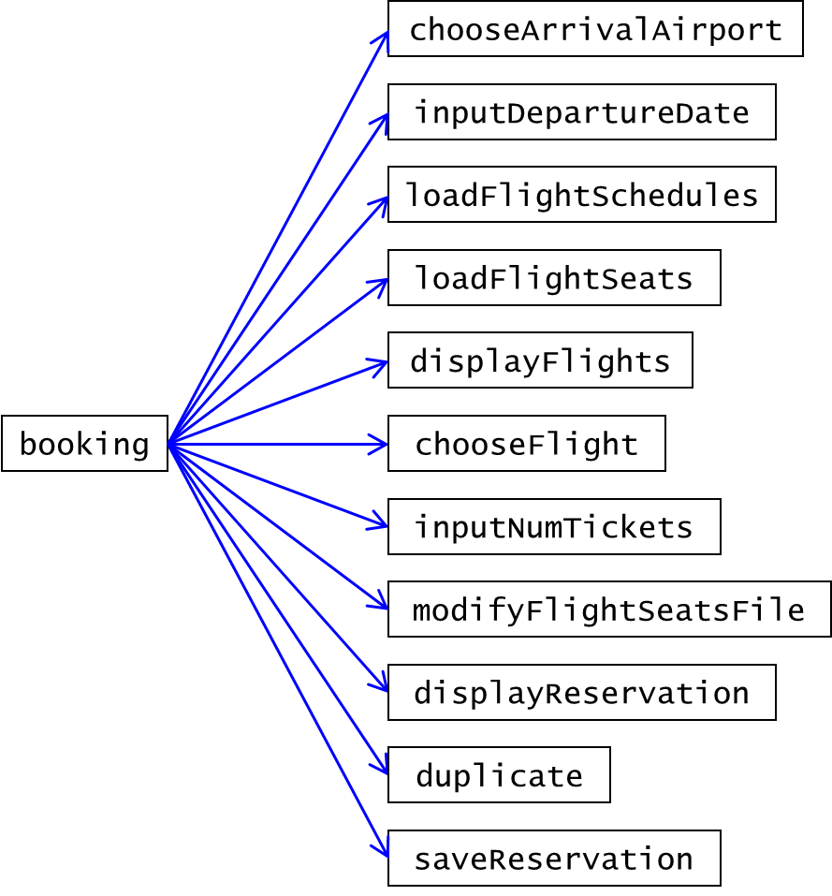

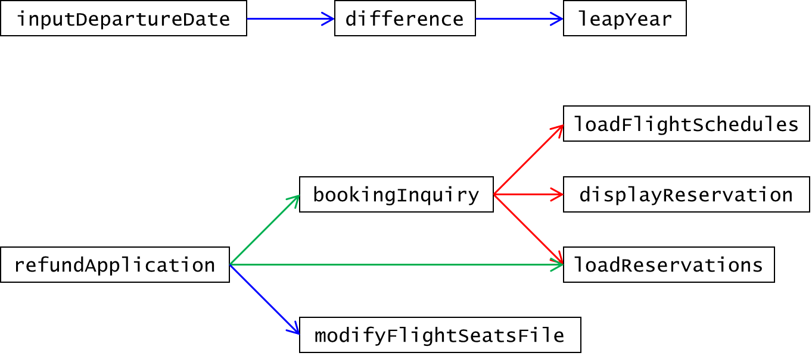

Full Fare

|  |  |  |  |  |  |  |  |  |  |  |  |
| --- | --- | --- | --- | --- | --- | --- | --- | --- | --- | --- | --- |
|  | Taipei | Taichung | Chiayi | Tainan | Kaohsiung | Hualien | Taitung | Penghu | Kinmen | Beigan | Nangan |
| Taipei | 0 | 0 | 0 | 0 | 0 | 1781 | 2460 | 2296 | 2618 | 2197 | 2197 |
| Taichung | 0 | 0 | 0 | 0 | 0 | 0 | 0 | 1769 | 2236 | 0 | 2686 |
| Chiayi | 0 | 0 | 0 | 0 | 0 | 0 | 0 | 1721 | 2217 | 0 | 0 |
| Tainan | 0 | 0 | 0 | 0 | 0 | 0 | 0 | 1697 | 2231 | 0 | 0 |
| Kaohsiung | 0 | 0 | 0 | 0 | 0 | 0 | 0 | 1876 | 2393 | 0 | 0 |
| Hualien | 1781 | 0 | 0 | 0 | 0 | 0 | 0 | 0 | 0 | 0 | 0 |
| Taitung | 2460 | 0 | 0 | 0 | 0 | 0 | 0 | 0 | 0 | 0 | 0 |
| Penghu | 2296 | 1769 | 1721 | 1697 | 1876 | 0 | 0 | 0 | 1768 | 0 | 0 |
| Kinmen | 2618 | 2236 | 2217 | 2231 | 2393 | 0 | 0 | 1768 | 0 | 0 | 0 |
| Beigan | 2197 | 0 | 0 | 0 | 0 | 0 | 0 | 0 | 0 | 0 | 0 |
| Nangan | 2197 | 2686 | 0 | 0 | 0 | 0 | 0 | 0 | 0 | 0 | 0 |

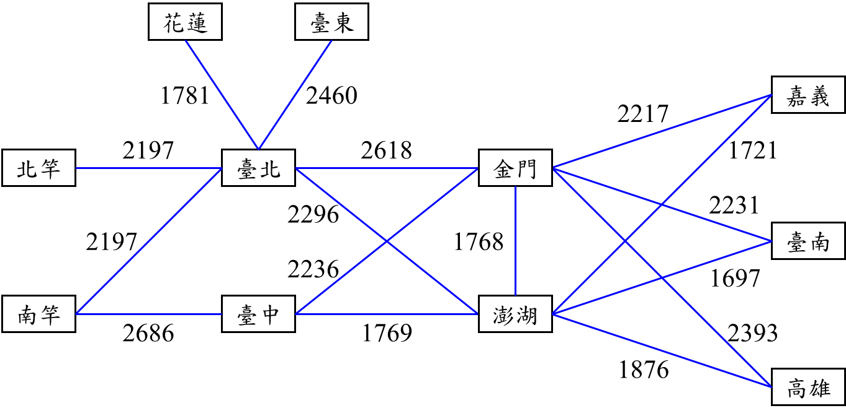

Airport code

|  |  |  |
| --- | --- | --- |
| Code | Airport | 機場 |
| 1 | Taipei | 臺北 |
| 2 | Taichung | 臺中 |
| 3 | Chiayi | 嘉義 |
| 4 | Tainan | 臺南 |
| 5 | Kaohsiung | 高雄 |
| 6 | Hualien | 花蓮 |
| 7 | Taitung | 臺東 |
| 8 | Penghu | 澎湖 |
| 9 | Kinmen | 金門 |
| 10 | Beigan | 北竿 |
| 11 | Nangan | 南竿 |

Flight Schedule.dat

|  |  |  |  |  |  |  |  |  |  |  |  |  |
| --- | --- | --- | --- | --- | --- | --- | --- | --- | --- | --- | --- | --- |
| Flight No. | Aircraft | Departure airport | Arrival airport | Departure time | Arrival time | Sun | Mon | Tue | Wed | Thu | Fri | Sat |
| 8971 | AT7 | 1 | 6 | 07:50 | 08:40 | 0 | 0 | 0 | 0 | 1 | 0 | 1 |
| 8977 | AT7 | 1 | 6 | 19:00 | 19:50 | 1 | 0 | 0 | 0 | 0 | 1 | 0 |
| 8972 | AT7 | 6 | 1 | 09:10 | 09:50 | 0 | 0 | 0 | 0 | 1 | 0 | 1 |
| 8978 | AT7 | 6 | 1 | 20:20 | 21:00 | 1 | 0 | 0 | 0 | 0 | 1 | 0 |
| 8721 | AT7 | 1 | 7 | 09:40 | 10:45 | 1 | 1 | 1 | 1 | 1 | 1 | 1 |
| 8725 | AT7 | 1 | 7 | 13:30 | 14:35 | 1 | 1 | 1 | 1 | 1 | 1 | 1 |
| 8727 | AT7 | 1 | 7 | 16:50 | 17:55 | 1 | 1 | 1 | 1 | 1 | 1 | 1 |
| 8729 | AT7 | 1 | 7 | 18:45 | 19:50 | 0 | 0 | 0 | 0 | 0 | 1 | 0 |
| 8722 | AT7 | 7 | 1 | 11:20 | 12:20 | 1 | 1 | 1 | 1 | 1 | 1 | 1 |
| 8726 | AT7 | 7 | 1 | 15:10 | 16:10 | 1 | 1 | 1 | 1 | 1 | 1 | 1 |
| 8728 | AT7 | 7 | 1 | 18:40 | 19:40 | 1 | 1 | 1 | 1 | 1 | 1 | 1 |
| 8730 | AT7 | 7 | 1 | 20:30 | 21:30 | 0 | 0 | 0 | 0 | 0 | 1 | 0 |
| 8605 | A321 | 1 | 8 | 08:00 | 08:50 | 0 | 1 | 1 | 1 | 1 | 1 | 1 |
| 9105 | AT7 | 1 | 8 | 09:50 | 10:50 | 1 | 0 | 0 | 0 | 0 | 0 | 0 |
| 9105 | AT7 | 1 | 8 | 10:30 | 11:30 | 0 | 0 | 0 | 0 | 1 | 0 | 1 |
| 8609 | A321 | 1 | 8 | 11:30 | 12:20 | 1 | 1 | 1 | 1 | 1 | 1 | 1 |
| 8615 | A321 | 1 | 8 | 15:00 | 15:50 | 1 | 0 | 0 | 0 | 0 | 0 | 0 |
| 8615 | A321 | 1 | 8 | 15:40 | 16:30 | 0 | 1 | 1 | 1 | 1 | 1 | 1 |
| 8625 | A321 | 1 | 8 | 18:30 | 19:20 | 1 | 0 | 0 | 0 | 0 | 0 | 0 |
| 8606 | A321 | 8 | 1 | 09:50 | 10:40 | 0 | 1 | 1 | 1 | 1 | 1 | 1 |
| 8610 | A321 | 8 | 1 | 13:20 | 14:10 | 1 | 1 | 1 | 1 | 1 | 1 | 1 |
| 9106 | AT7 | 8 | 1 | 15:40 | 16:35 | 1 | 0 | 0 | 0 | 1 | 0 | 1 |
| 8616 | A321 | 8 | 1 | 16:40 | 17:30 | 1 | 0 | 0 | 0 | 0 | 0 | 0 |
| 8616 | A321 | 8 | 1 | 17:20 | 18:10 | 0 | 1 | 1 | 1 | 1 | 1 | 1 |
| 8626 | A321 | 8 | 1 | 20:10 | 21:00 | 1 | 0 | 0 | 0 | 0 | 0 | 0 |
| 8801 | A321 | 1 | 9 | 07:00 | 08:05 | 1 | 1 | 1 | 1 | 1 | 1 | 1 |
| 8809 | AT7 | 1 | 9 | 09:00 | 10:20 | 1 | 1 | 0 | 0 | 0 | 1 | 0 |
| 9205 | A321 | 1 | 9 | 09:50 | 10:55 | 0 | 0 | 0 | 0 | 0 | 1 | 0 |
| 9205 | A321 | 1 | 9 | 10:00 | 11:05 | 0 | 0 | 0 | 0 | 0 | 0 | 1 |
| 8811 | A321 | 1 | 9 | 10:45 | 11:50 | 1 | 1 | 1 | 1 | 1 | 1 | 1 |
| 8821 | A321 | 1 | 9 | 13:50 | 14:55 | 1 | 1 | 1 | 1 | 1 | 1 | 1 |
| 9207 | A321 | 1 | 9 | 15:00 | 16:05 | 0 | 0 | 1 | 0 | 1 | 0 | 0 |
| 9207 | A321 | 1 | 9 | 15:40 | 16:45 | 1 | 0 | 0 | 0 | 0 | 0 | 0 |
| 8835 | A321 | 1 | 9 | 18:00 | 19:05 | 1 | 1 | 1 | 1 | 1 | 1 | 1 |
| 8802 | A321 | 9 | 1 | 08:55 | 09:55 | 1 | 1 | 1 | 1 | 1 | 1 | 1 |
| 9206 | A321 | 9 | 1 | 11:50 | 12:50 | 0 | 0 | 0 | 0 | 0 | 1 | 0 |
| 9206 | A321 | 9 | 1 | 11:55 | 12:55 | 0 | 0 | 0 | 0 | 0 | 0 | 1 |
| 8812 | A321 | 9 | 1 | 12:40 | 13:40 | 1 | 1 | 1 | 1 | 1 | 1 | 1 |
| 8816 | AT7 | 9 | 1 | 14:30 | 15:40 | 1 | 1 | 0 | 0 | 0 | 1 | 0 |
| 8822 | A321 | 9 | 1 | 15:50 | 16:50 | 1 | 1 | 1 | 1 | 1 | 1 | 1 |
| 9208 | A321 | 9 | 1 | 17:00 | 18:00 | 0 | 0 | 1 | 0 | 1 | 0 | 0 |
| 9208 | A321 | 9 | 1 | 17:40 | 18:40 | 1 | 0 | 0 | 0 | 0 | 0 | 0 |
| 8836 | A321 | 9 | 1 | 20:10 | 21:10 | 1 | 1 | 1 | 1 | 1 | 1 | 1 |
| 8781 | AT7 | 1 | 10 | 06:40 | 07:35 | 1 | 1 | 1 | 1 | 1 | 1 | 1 |
| 8789 | AT7 | 1 | 10 | 15:20 | 16:15 | 1 | 1 | 1 | 1 | 1 | 1 | 1 |
| 8782 | AT7 | 10 | 1 | 08:10 | 09:00 | 1 | 1 | 1 | 1 | 1 | 1 | 1 |
| 8790 | AT7 | 10 | 1 | 16:50 | 17:40 | 1 | 1 | 1 | 1 | 1 | 1 | 1 |
| 8751 | AT7 | 1 | 11 | 06:30 | 07:25 | 1 | 1 | 1 | 1 | 1 | 1 | 1 |
| 8755 | AT7 | 1 | 11 | 09:30 | 10:25 | 1 | 1 | 1 | 1 | 1 | 1 | 1 |
| 8775 | AT7 | 1 | 11 | 12:15 | 13:10 | 0 | 1 | 1 | 1 | 1 | 0 | 1 |
| 8759 | AT7 | 1 | 11 | 13:05 | 14:00 | 1 | 1 | 1 | 1 | 1 | 1 | 1 |
| 8761 | AT7 | 1 | 11 | 14:00 | 14:55 | 1 | 1 | 1 | 1 | 1 | 1 | 1 |
| 8767 | AT7 | 1 | 11 | 16:00 | 16:55 | 1 | 1 | 1 | 1 | 1 | 1 | 1 |
| 8752 | AT7 | 11 | 1 | 08:00 | 08:50 | 1 | 1 | 1 | 1 | 1 | 1 | 1 |
| 8756 | AT7 | 11 | 1 | 11:25 | 12:15 | 1 | 1 | 1 | 1 | 1 | 1 | 1 |
| 8758 | AT7 | 11 | 1 | 12:30 | 13:20 | 1 | 1 | 1 | 1 | 1 | 1 | 1 |
| 8760 | AT7 | 11 | 1 | 13:45 | 14:35 | 0 | 1 | 1 | 1 | 1 | 0 | 1 |
| 8762 | AT7 | 11 | 1 | 14:35 | 15:25 | 1 | 1 | 1 | 1 | 1 | 1 | 1 |
| 8768 | AT7 | 11 | 1 | 17:30 | 18:20 | 1 | 1 | 1 | 1 | 1 | 1 | 1 |
| 8631 | AT7 | 2 | 8 | 08:30 | 09:15 | 1 | 1 | 1 | 1 | 1 | 1 | 1 |
| 8635 | AT7 | 2 | 8 | 11:30 | 12:15 | 1 | 1 | 1 | 1 | 1 | 1 | 1 |
| 8639 | A321 | 2 | 8 | 15:10 | 15:50 | 1 | 0 | 0 | 0 | 0 | 0 | 0 |
| 8639 | AT7 | 2 | 8 | 15:10 | 15:55 | 0 | 1 | 1 | 1 | 1 | 1 | 1 |
| 8651 | AT7 | 2 | 8 | 18:00 | 18:45 | 1 | 1 | 1 | 1 | 1 | 1 | 1 |
| 8632 | AT7 | 8 | 2 | 10:00 | 10:40 | 1 | 1 | 1 | 1 | 1 | 1 | 1 |
| 8636 | AT7 | 8 | 2 | 13:00 | 13:40 | 1 | 1 | 1 | 1 | 1 | 1 | 1 |
| 8640 | AT7 | 8 | 2 | 16:30 | 17:10 | 0 | 1 | 1 | 1 | 1 | 1 | 1 |
| 8640 | A321 | 8 | 2 | 16:40 | 17:20 | 1 | 0 | 0 | 0 | 0 | 0 | 0 |
| 8652 | AT7 | 8 | 2 | 19:20 | 20:00 | 1 | 1 | 1 | 1 | 1 | 1 | 1 |
| 8955 | AT7 | 2 | 9 | 08:00 | 09:05 | 1 | 1 | 1 | 1 | 1 | 0 | 1 |
| 8957 | A321 | 2 | 9 | 11:20 | 12:10 | 0 | 0 | 0 | 0 | 0 | 1 | 0 |
| 8957 | AT7 | 2 | 9 | 11:20 | 12:25 | 1 | 1 | 1 | 1 | 1 | 0 | 1 |
| 8961 | AT7 | 2 | 9 | 14:20 | 15:25 | 1 | 1 | 1 | 1 | 1 | 1 | 1 |
| 8965 | AT7 | 2 | 9 | 17:35 | 18:40 | 0 | 1 | 1 | 1 | 1 | 1 | 1 |
| 8965 | A321 | 2 | 9 | 18:15 | 19:05 | 1 | 0 | 0 | 0 | 0 | 0 | 0 |
| 8956 | AT7 | 9 | 2 | 09:50 | 10:50 | 1 | 1 | 1 | 1 | 1 | 0 | 1 |
| 8960 | A321 | 9 | 2 | 13:30 | 14:20 | 0 | 0 | 0 | 0 | 0 | 1 | 0 |
| 8960 | AT7 | 9 | 2 | 13:30 | 14:30 | 1 | 1 | 1 | 1 | 1 | 0 | 1 |
| 8962 | AT7 | 9 | 2 | 16:00 | 17:00 | 1 | 1 | 1 | 1 | 1 | 1 | 1 |
| 8966 | AT7 | 9 | 2 | 19:30 | 20:30 | 0 | 1 | 1 | 1 | 1 | 1 | 1 |
| 8966 | A321 | 9 | 2 | 19:55 | 20:45 | 1 | 0 | 0 | 0 | 0 | 0 | 0 |
| 8735 | AT7 | 2 | 11 | 10:40 | 11:45 | 1 | 1 | 1 | 1 | 1 | 1 | 1 |
| 8736 | AT7 | 11 | 2 | 15:40 | 16:45 | 1 | 1 | 1 | 1 | 1 | 1 | 1 |
| 8661 | AT7 | 3 | 8 | 15:40 | 16:10 | 1 | 1 | 1 | 1 | 1 | 1 | 1 |
| 8662 | AT7 | 8 | 3 | 14:30 | 15:00 | 1 | 1 | 1 | 1 | 1 | 1 | 1 |
| 8901 | AT7 | 3 | 9 | 12:40 | 13:30 | 1 | 1 | 0 | 0 | 0 | 1 | 0 |
| 8902 | AT7 | 9 | 3 | 11:00 | 11:55 | 1 | 1 | 0 | 0 | 0 | 1 | 0 |
| 8675 | AT7 | 4 | 8 | 07:20 | 07:50 | 1 | 1 | 1 | 1 | 1 | 1 | 1 |
| 8681 | AT7 | 4 | 8 | 13:10 | 13:40 | 1 | 1 | 1 | 1 | 1 | 1 | 1 |
| 8683 | AT7 | 4 | 8 | 17:10 | 17:40 | 1 | 1 | 1 | 1 | 1 | 1 | 1 |
| 8676 | AT7 | 8 | 4 | 08:35 | 09:10 | 1 | 1 | 1 | 1 | 1 | 1 | 1 |
| 8680 | AT7 | 8 | 4 | 14:20 | 14:55 | 1 | 1 | 1 | 1 | 1 | 1 | 1 |
| 8682 | AT7 | 8 | 4 | 15:50 | 16:25 | 1 | 1 | 1 | 1 | 1 | 1 | 1 |
| 8981 | AT7 | 4 | 9 | 09:50 | 10:40 | 1 | 1 | 1 | 1 | 1 | 1 | 1 |
| 8991 | AT7 | 4 | 9 | 15:40 | 16:30 | 1 | 1 | 1 | 1 | 1 | 1 | 1 |
| 8982 | AT7 | 9 | 4 | 11:30 | 12:25 | 1 | 1 | 1 | 1 | 1 | 1 | 1 |
| 8992 | AT7 | 9 | 4 | 17:10 | 18:05 | 1 | 1 | 1 | 1 | 1 | 1 | 1 |
| 8689 | AT7 | 5 | 8 | 07:00 | 07:40 | 1 | 1 | 1 | 1 | 1 | 1 | 1 |
| 8691 | A321 | 5 | 8 | 08:00 | 08:40 | 0 | 0 | 0 | 0 | 0 | 1 | 1 |
| 8695 | AT7 | 5 | 8 | 09:50 | 10:30 | 1 | 1 | 1 | 1 | 1 | 1 | 0 |
| 8697 | AT7 | 5 | 8 | 10:50 | 11:30 | 1 | 1 | 1 | 1 | 1 | 1 | 1 |
| 8701 | AT7 | 5 | 8 | 13:00 | 13:40 | 1 | 1 | 1 | 1 | 1 | 1 | 1 |
| 8707 | AT7 | 5 | 8 | 14:30 | 15:10 | 1 | 1 | 1 | 1 | 1 | 1 | 1 |
| 8715 | A321 | 5 | 8 | 18:00 | 18:40 | 1 | 1 | 0 | 0 | 0 | 1 | 0 |
| 8715 | AT7 | 5 | 8 | 18:20 | 19:00 | 0 | 0 | 1 | 1 | 1 | 0 | 1 |
| 8690 | AT7 | 8 | 5 | 08:20 | 09:00 | 1 | 1 | 1 | 1 | 1 | 1 | 1 |
| 8692 | A321 | 8 | 5 | 09:30 | 10:10 | 0 | 0 | 0 | 0 | 0 | 1 | 1 |
| 8696 | AT7 | 8 | 5 | 11:10 | 11:50 | 1 | 1 | 1 | 1 | 1 | 1 | 1 |
| 8698 | AT7 | 8 | 5 | 12:30 | 13:10 | 1 | 1 | 1 | 1 | 1 | 1 | 1 |
| 8710 | AT7 | 8 | 5 | 16:50 | 17:30 | 1 | 1 | 1 | 1 | 1 | 1 | 1 |
| 8712 | AT7 | 8 | 5 | 18:30 | 19:10 | 1 | 1 | 1 | 1 | 1 | 1 | 1 |
| 8716 | AT7 | 8 | 5 | 19:30 | 20:10 | 0 | 0 | 1 | 1 | 1 | 0 | 1 |
| 8716 | A321 | 8 | 5 | 19:30 | 20:10 | 1 | 1 | 0 | 0 | 0 | 1 | 0 |
| 8911 | AT7 | 5 | 9 | 07:30 | 08:35 | 1 | 1 | 1 | 1 | 1 | 1 | 1 |
| 8917 | A321 | 5 | 9 | 11:10 | 12:00 | 1 | 1 | 1 | 1 | 1 | 1 | 1 |
| 8921 | AT7 | 5 | 9 | 14:00 | 15:05 | 1 | 1 | 1 | 1 | 1 | 1 | 0 |
| 8927 | A321 | 5 | 9 | 17:30 | 18:20 | 0 | 0 | 0 | 0 | 0 | 0 | 1 |
| 8927 | AT7 | 5 | 9 | 17:30 | 18:35 | 1 | 1 | 1 | 1 | 1 | 1 | 0 |
| 8912 | AT7 | 9 | 5 | 09:10 | 10:10 | 1 | 1 | 1 | 1 | 1 | 1 | 1 |
| 8918 | A321 | 9 | 5 | 13:10 | 14:00 | 1 | 1 | 1 | 1 | 1 | 1 | 1 |
| 8922 | AT7 | 9 | 5 | 15:40 | 16:40 | 1 | 1 | 1 | 1 | 1 | 1 | 0 |
| 8928 | A321 | 9 | 5 | 19:20 | 20:10 | 0 | 0 | 0 | 0 | 0 | 0 | 1 |
| 8928 | AT7 | 9 | 5 | 19:20 | 20:20 | 1 | 1 | 1 | 1 | 1 | 1 | 1 |
| 8995 | AT7 | 8 | 9 | 12:40 | 13:20 | 1 | 0 | 0 | 0 | 1 | 0 | 1 |
| 8996 | AT7 | 9 | 8 | 14:05 | 14:50 | 1 | 0 | 0 | 0 | 1 | 0 | 1 |